**RDS-POC**

For a 3-tier application (typically frontend, backend, and database), we can use Docker Compose to orchestrate the deployment

Install docker-compose

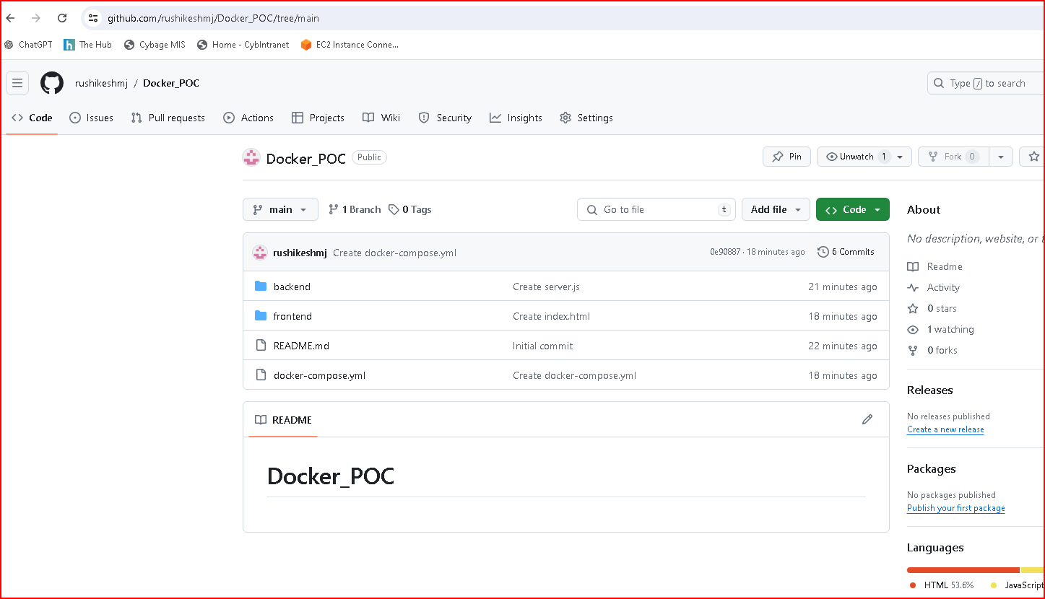

**Clone the project in new directory**

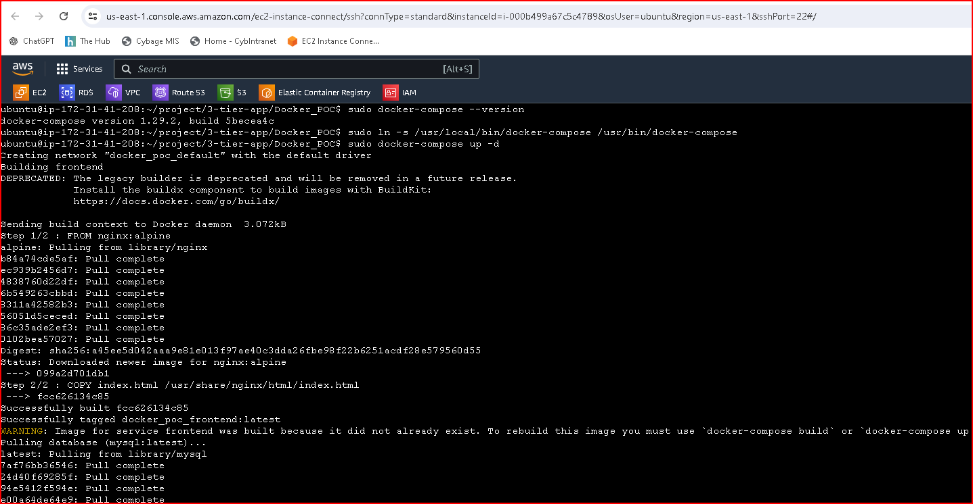

**sudo docker-compose up –d**

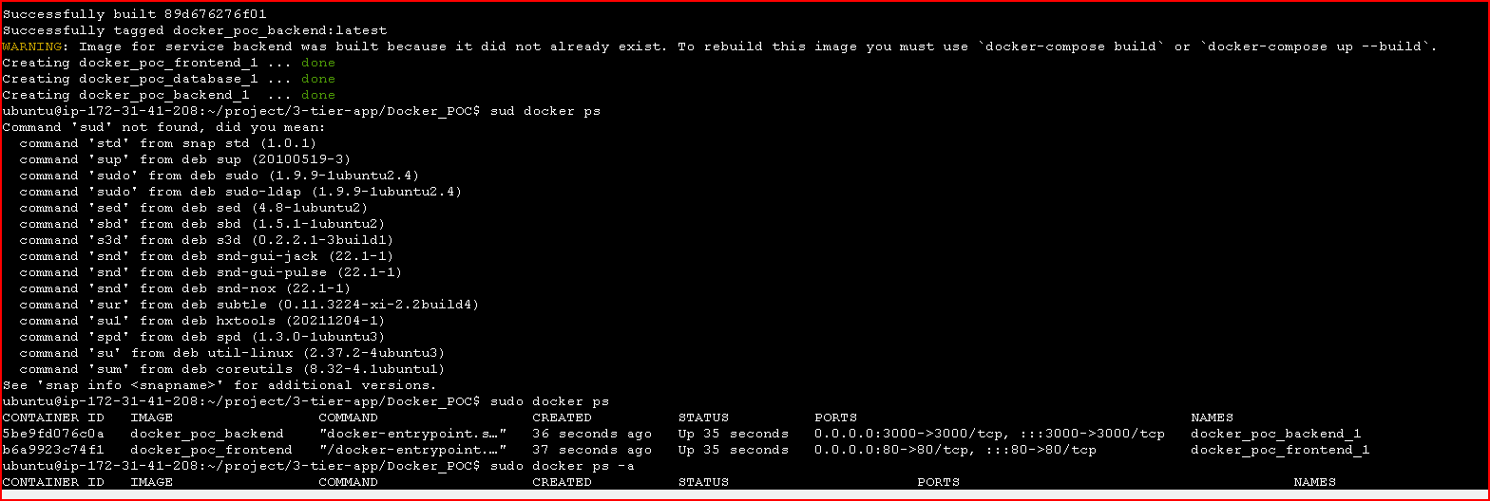

**Frontend**

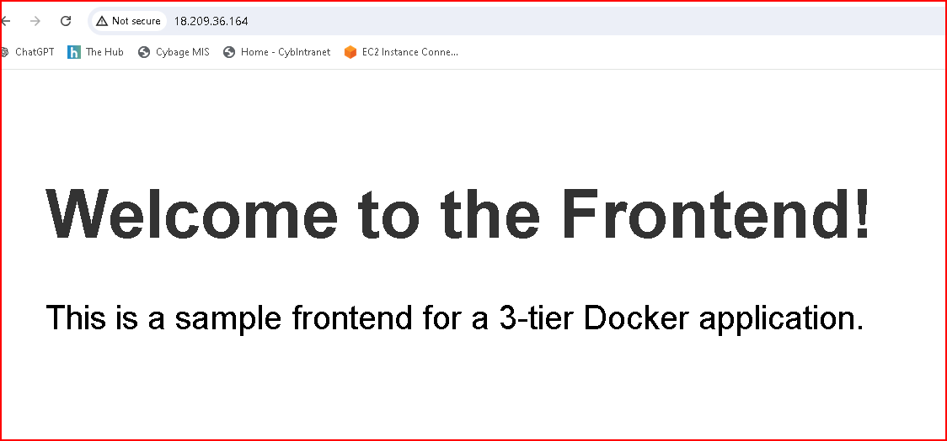

create a bastion host in public subnet in same vpc and accessing rds instance from it

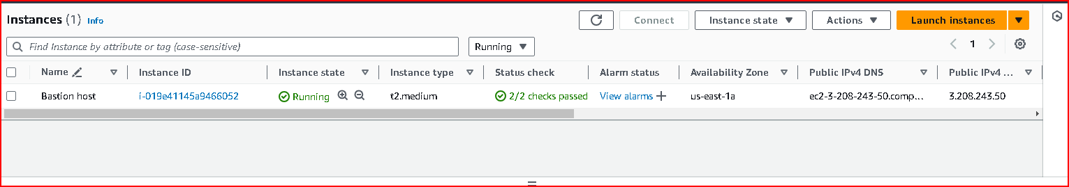

Create a iam user and provide necessary permissions by attaching policy for taking backup and retention

**Create snapshot from aws cli** 

**Succesfully created Snapshot**

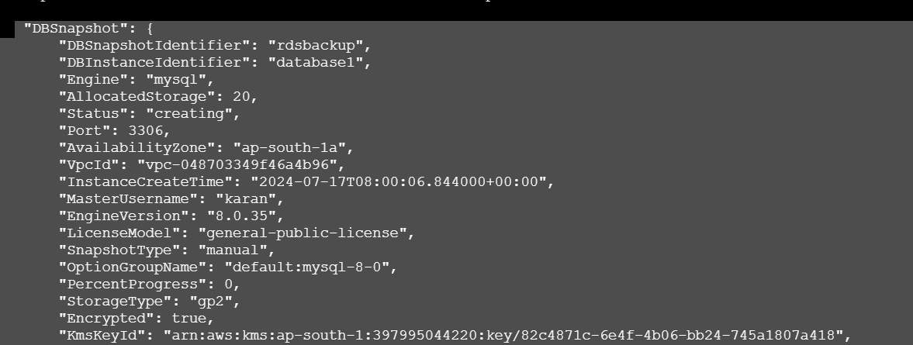

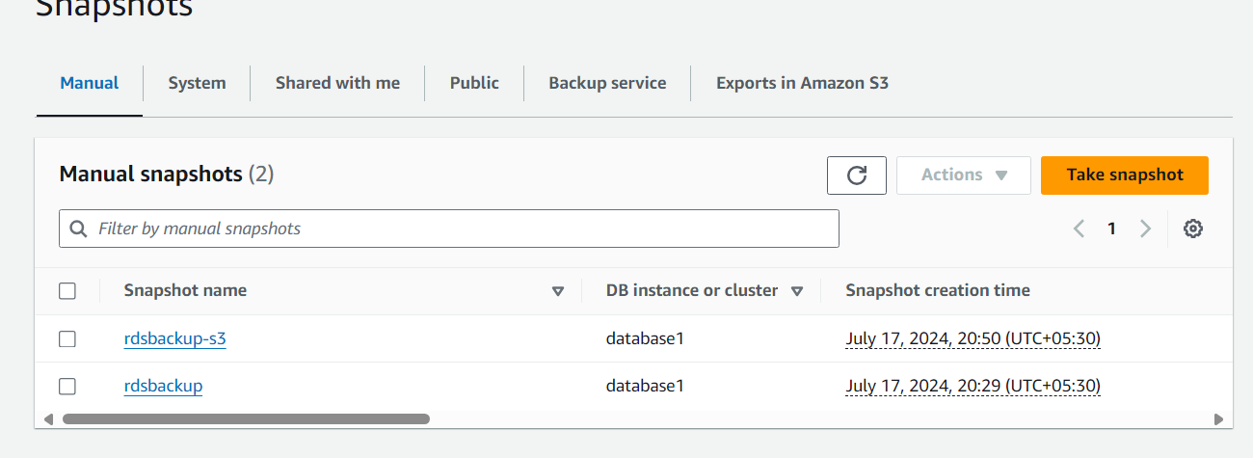

**Export the snapshot to my S3 bucket**

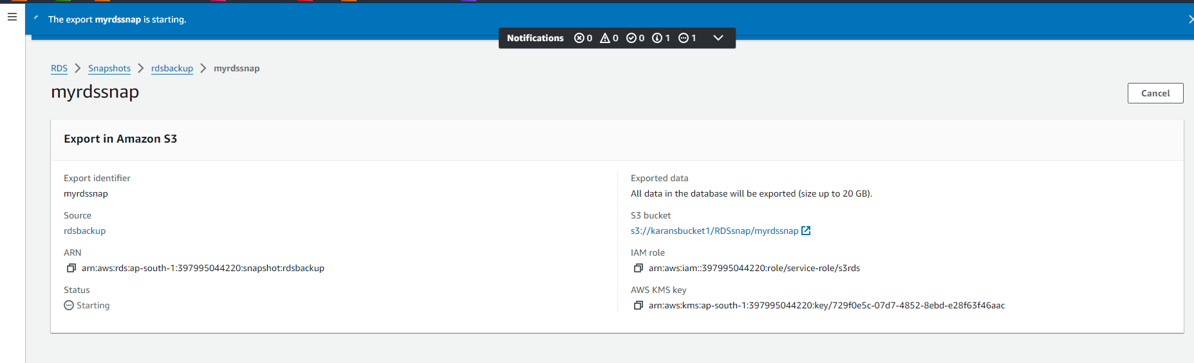

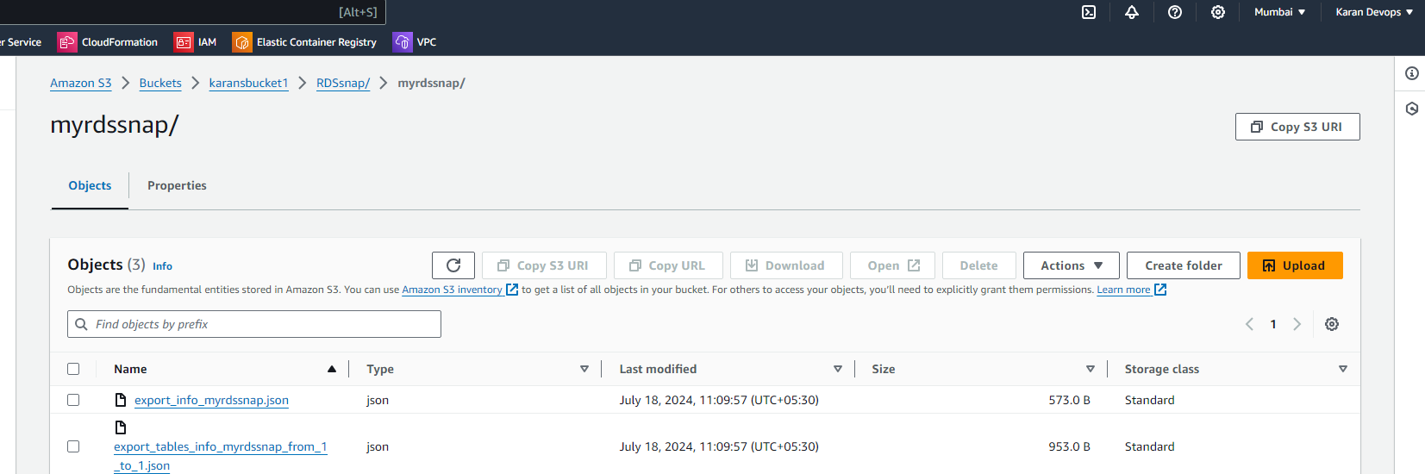 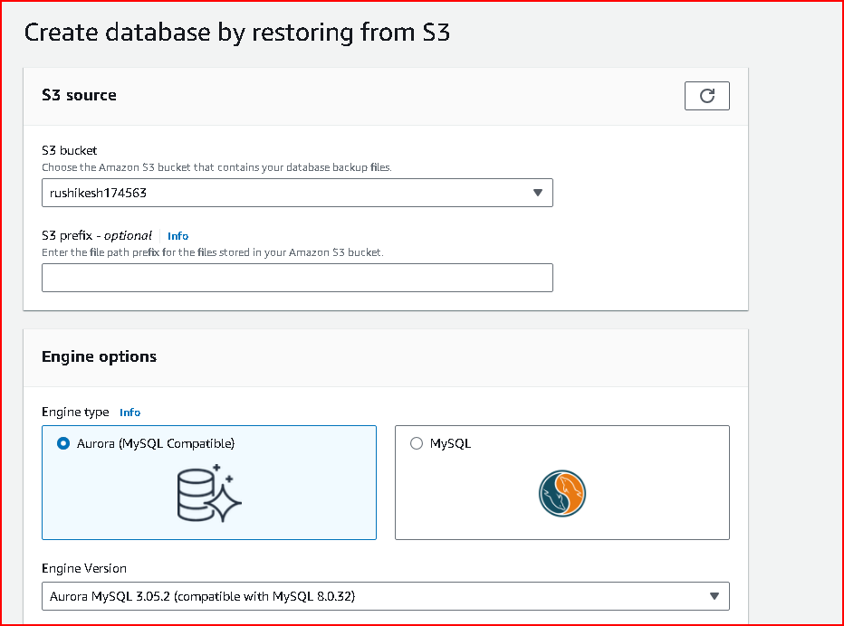

**Create the database by restoring the data from s3**

